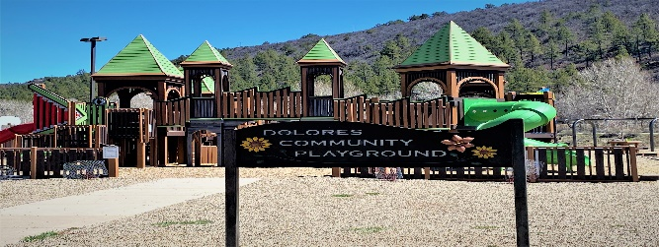
AGENDA
TOWN OF DOLORES COLORADO
PARK/PLAYGROUND ADVISORY COMMITTEE MEETING
November 9th, 2023, 6:00 P.M.
In Person at 420 Central Ave, or
Virtually, please see the Town Website at:
https://townofdolores.colorado.gov

1. CALL TO ORDER
2. ROLL CALL
3. IDENTIFICATION OF ACTUAL OR PERCEIVED CONFLICTS OF INTEREST
4. ACTION/APPROVAL OF AGENDA:
5. ACTION/APPROVAL OF THE MINUTES From the September 14th & October 12th meeting
5. CITIZENS COMMENTS: (5 minutes only): Citizens may comment at this time ONLY.
6. CONTINUING BUSINESS/DISCUSSION:
6.1 Discussion: Community Garden
6.2 Discussion: GOCO Grant Update
6.3 Discussion: Parks Committee Public Outreach
6.4 Discussion: Adult Exercise Equipment
7. New Business:
7.1 Welcome New Parks Committee Commissioner Audrey Mosher
8. Adjournment

