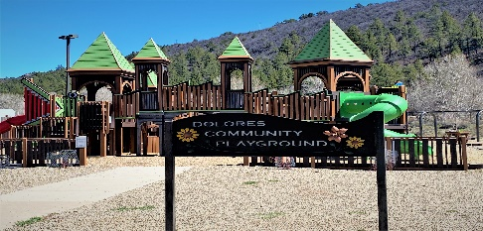

AGENDA
DOLORES PARKS /PLAYGOUND ADVISORY COMMITTEE
OCTOBER 12TH, 2023, 6:00 P.M.
MEETING WIL BE HELD AT DOLORES TOWN HALL 420 CENTRAL AVENUE.
https://townofdolores.colorado.gov
1. CALL TO ORDER
2. ROLL CALL:
3. INDENTIFICATION OF ACTUAL OR PERCEIVED CONFLICTS OF INTEREST
4. ACTION/APPROVAL OF THE AGENDA
5. ACTION APPROVAL OF THE MINUTES
6. CITIZENS COMMENTS: (5 minutes only) Citizens may comment at this time only.
7. NEW BUSINESS/DUSCUSSION:
- Possible Action: Recommendation to the Board to place Audrey Mosher as Commissioner for vacant seat on Parks Committee.
- Parks Committee Public Outreach
8. CONTINUING BUSINESS/DISCUSSION:
- GOCO Grant Update: Listening session and Harvestfest Booth.
9. UPDATES ON CURRENT PROJECTS:
- Community Garden
- Adult Exercise Equipment
10. Adjournment:

